**ASSIGNMENT-3**

**REQURIMENT-1:**

 Training can be registred without overlap, can register for a particular training only once. (Customize with Power Apps)

First create a list in our web site i.e., Requriment

In online share point, go to our site ->site contents->new->list.

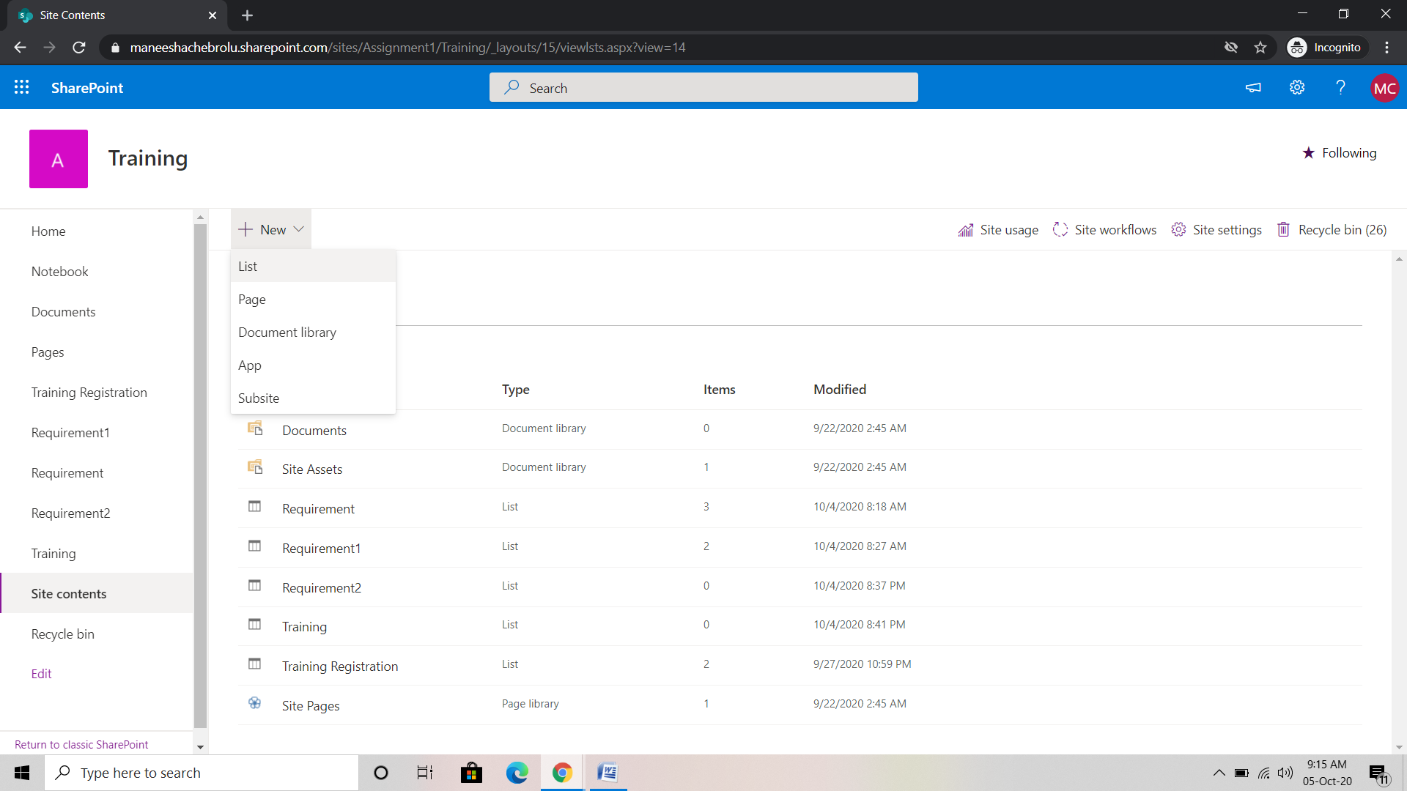

Requriment list is created with columns Gender, Designation, Date Of joining, Salary and course.

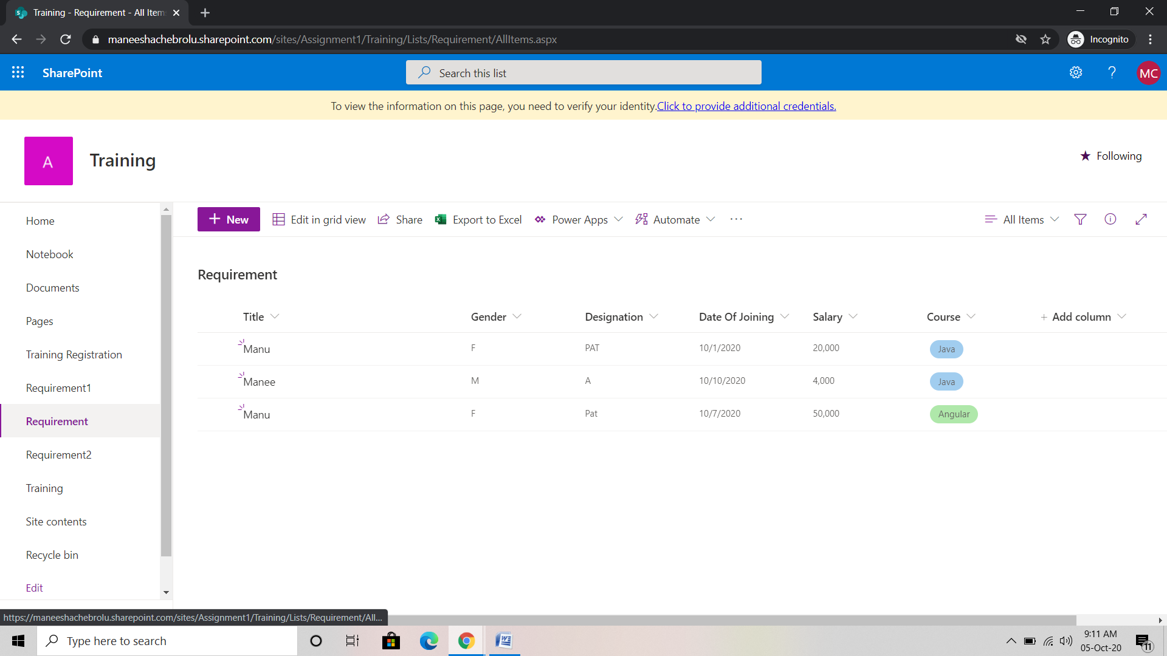

Next go to the power apps ->custom forms.

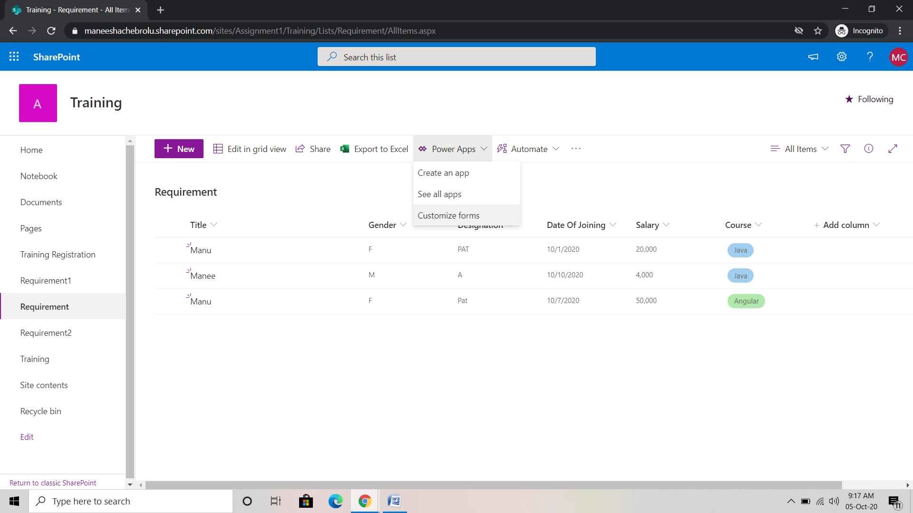

Power apps page is open like given picture.

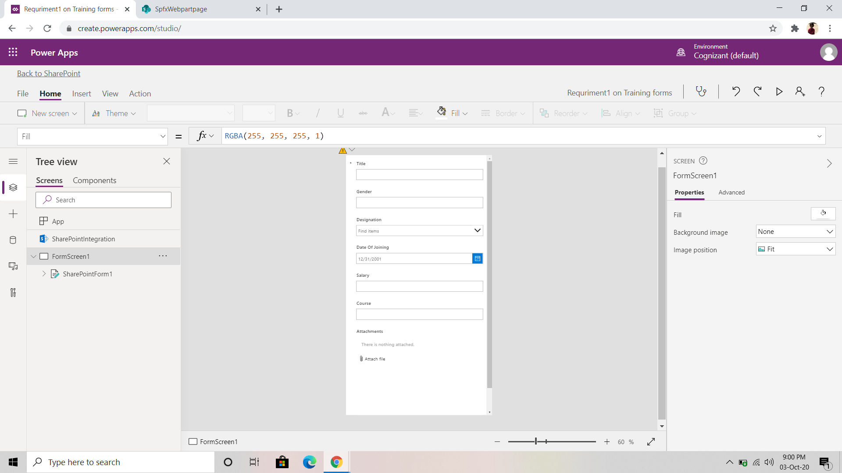

In power apps, select Share point integration and in data source drop down select On save. In fx function write the code for validation.

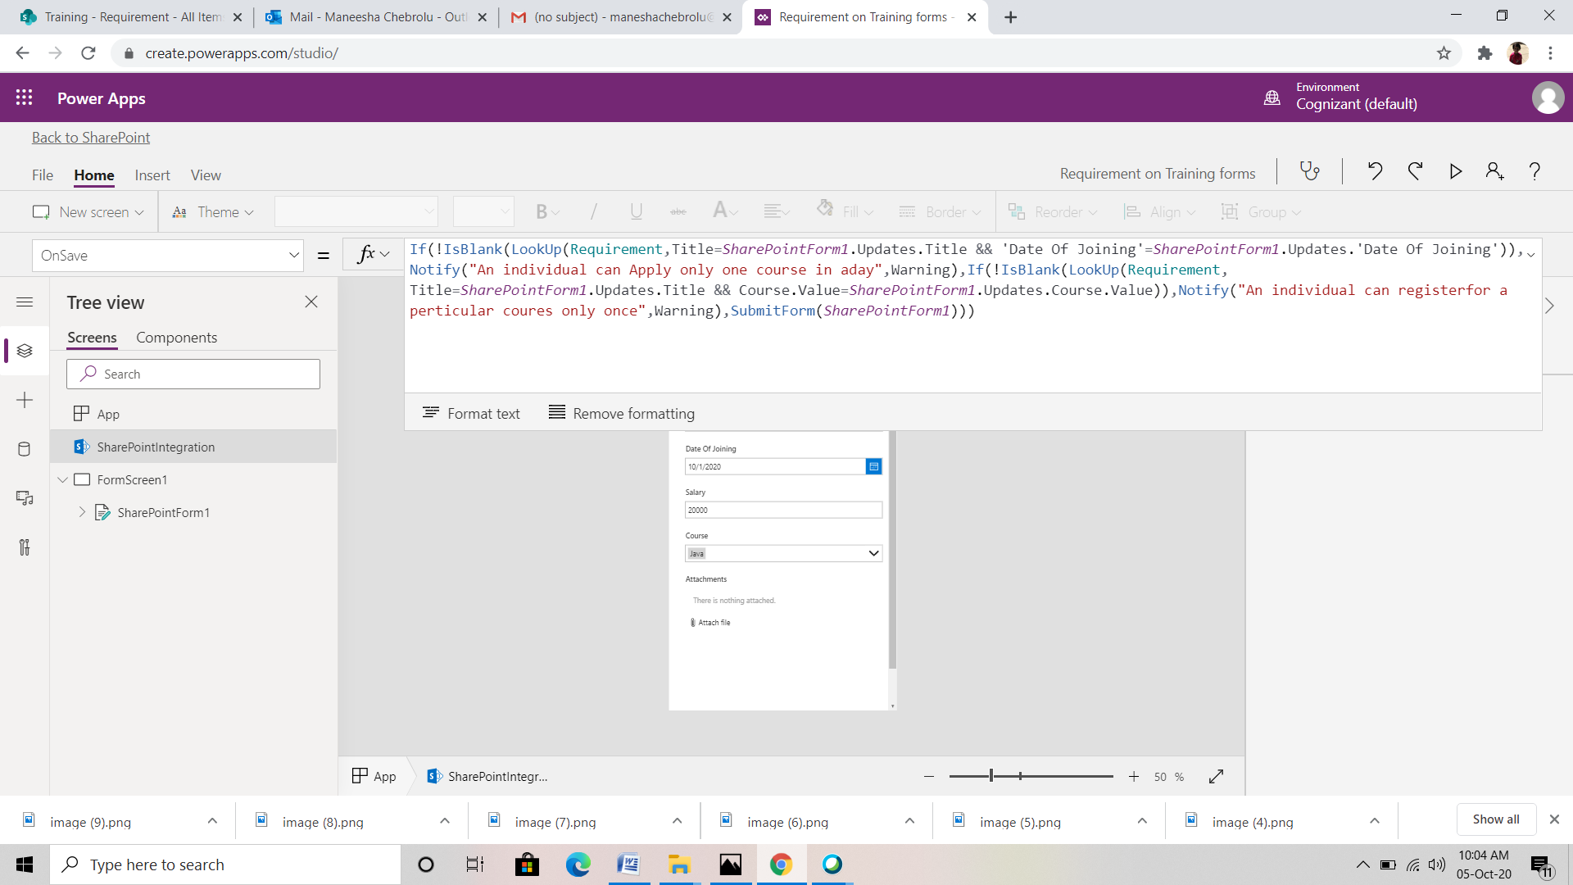

Next save and publish our site

File-> save

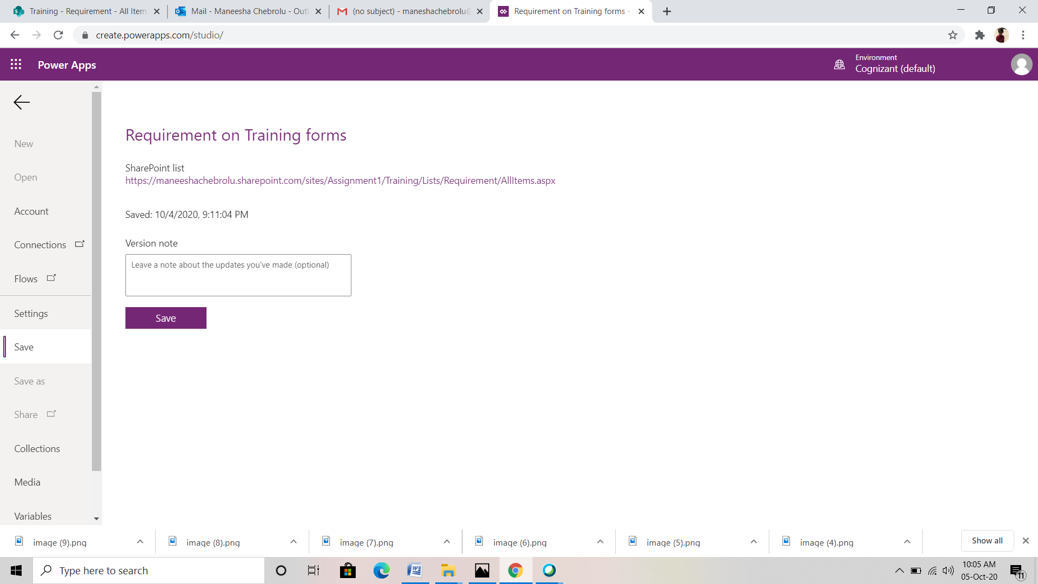

Save->publish to share point.

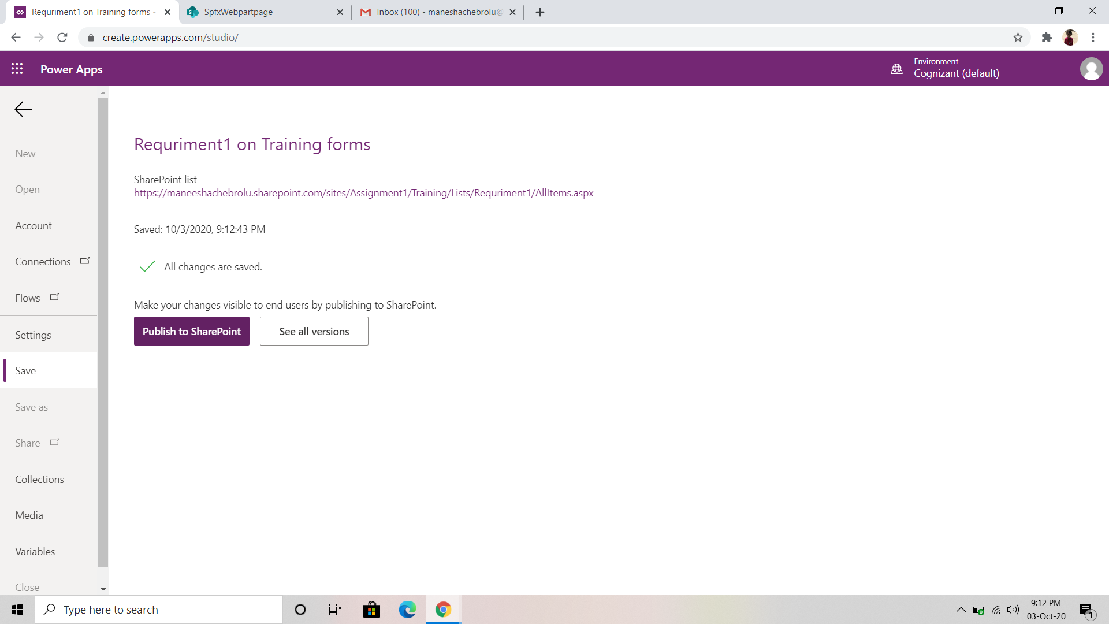

Next go to our site and fill the form and check the validation for overlapping details.

Our form is re designed using power apps

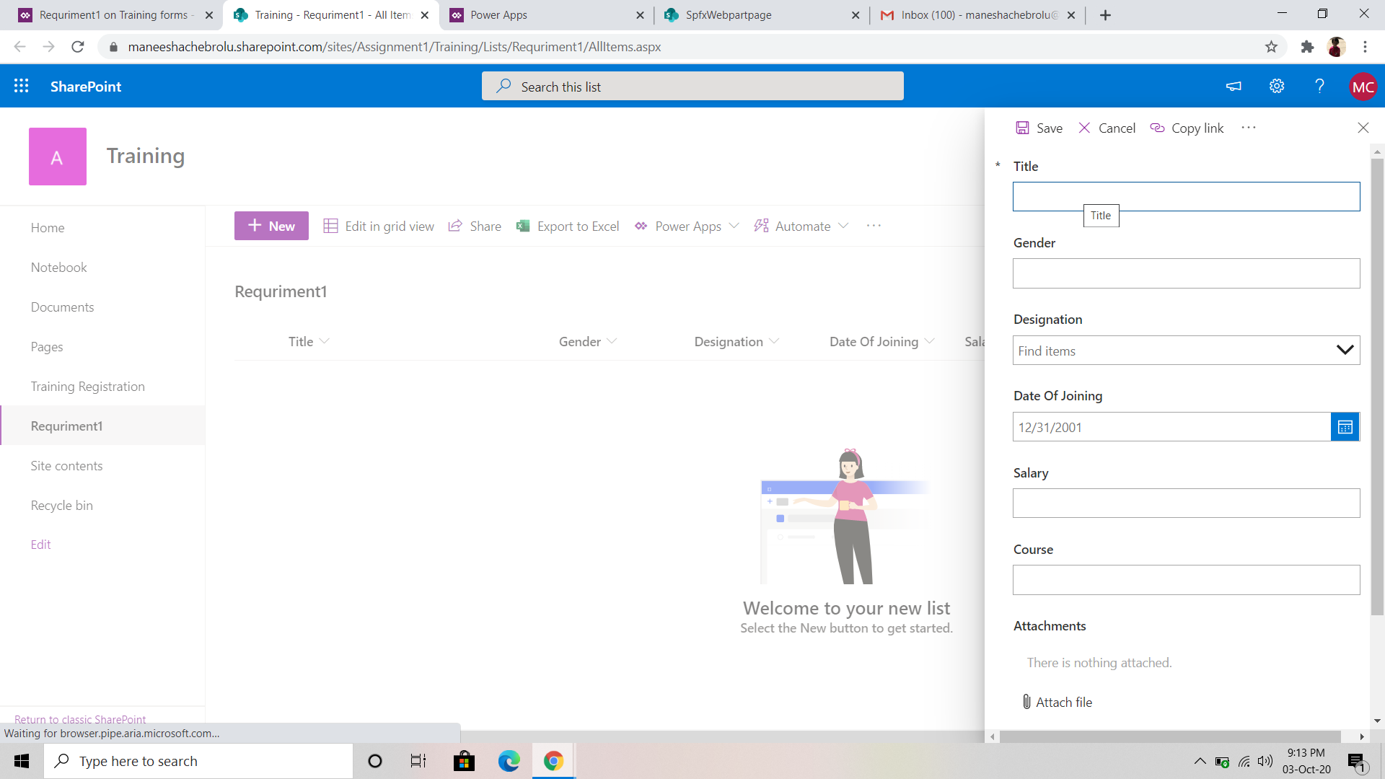

If a person is registered for same date of joining and name it shows an error message like

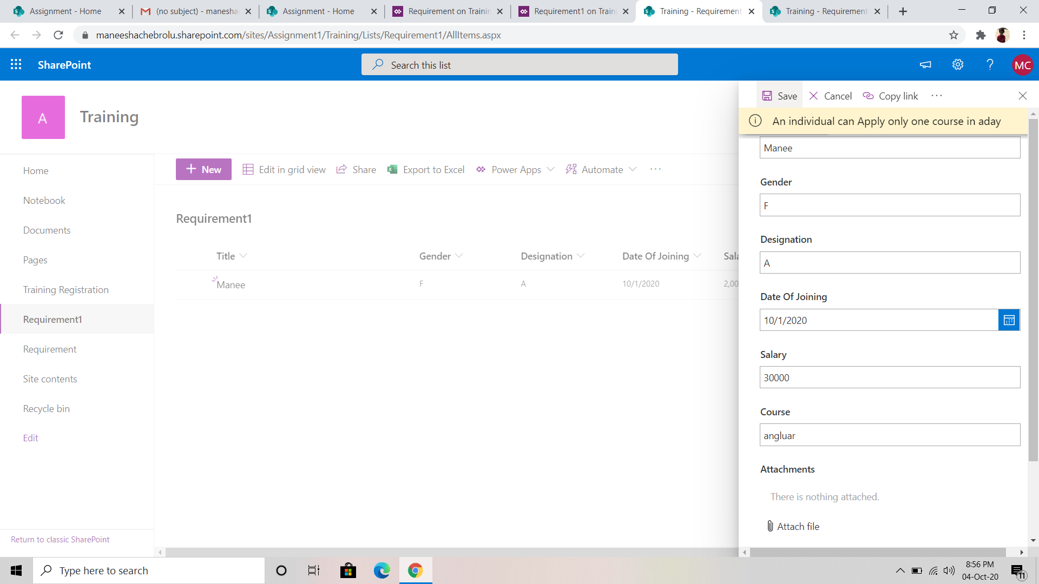

If a person is registered with same name and same course it displays an error message like

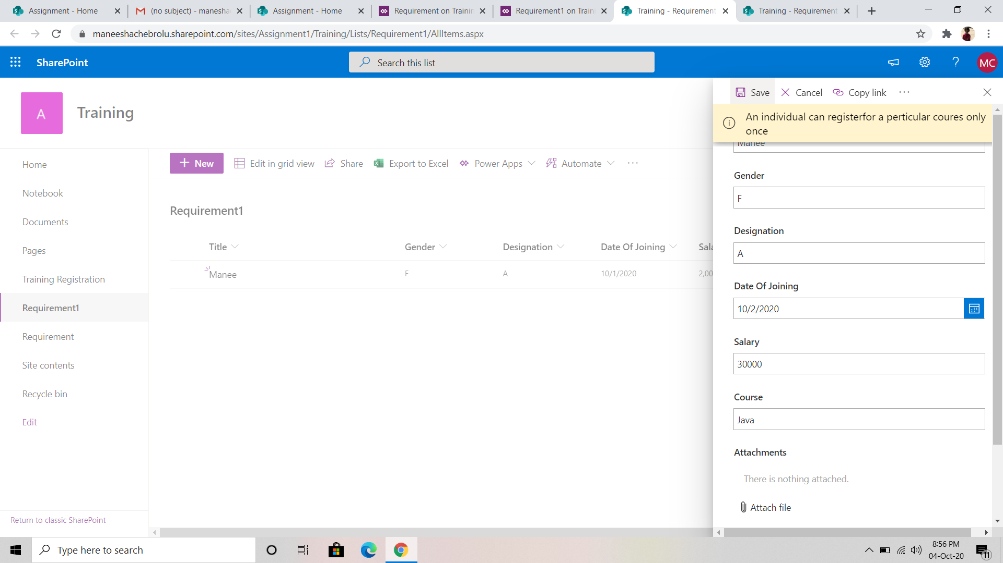

**REQURIMENT-2:**

On Cancellation of the training by organizer, send an email and cancel all tasks (Power App and Power Automate)

In online share point, go to our site ->site contents->new->list.



Here we have to create two lists names like requriment 2 and training

In requriment 2 list consists of columns like Trianing name, Trainer name and status.

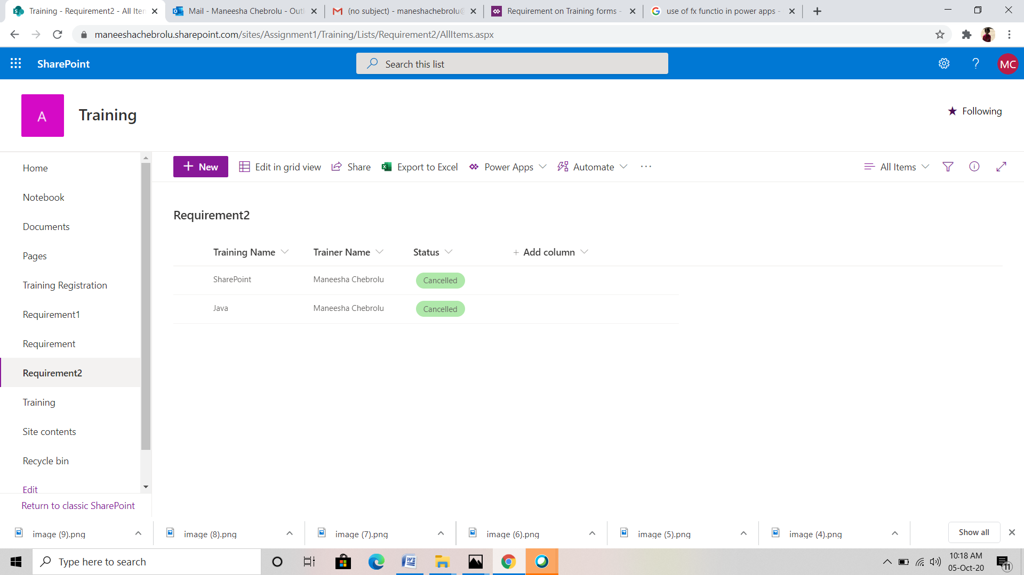

Training list consists of clolumns like employee name ,training name, status, employee id etc..

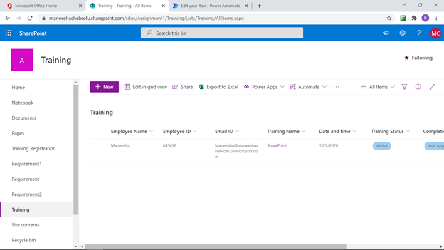

Next go to power automata it open as shown below

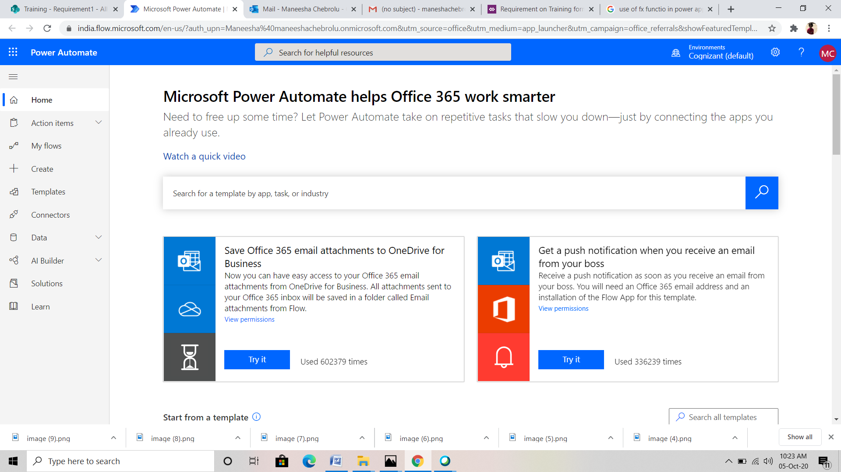

Go to create->Automated flow.

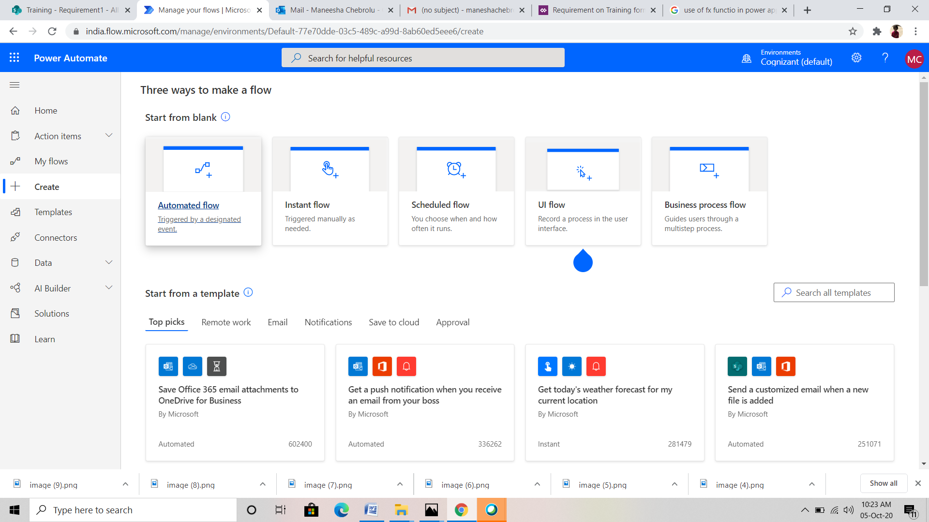

Next create an automated flow. select when an item is modified

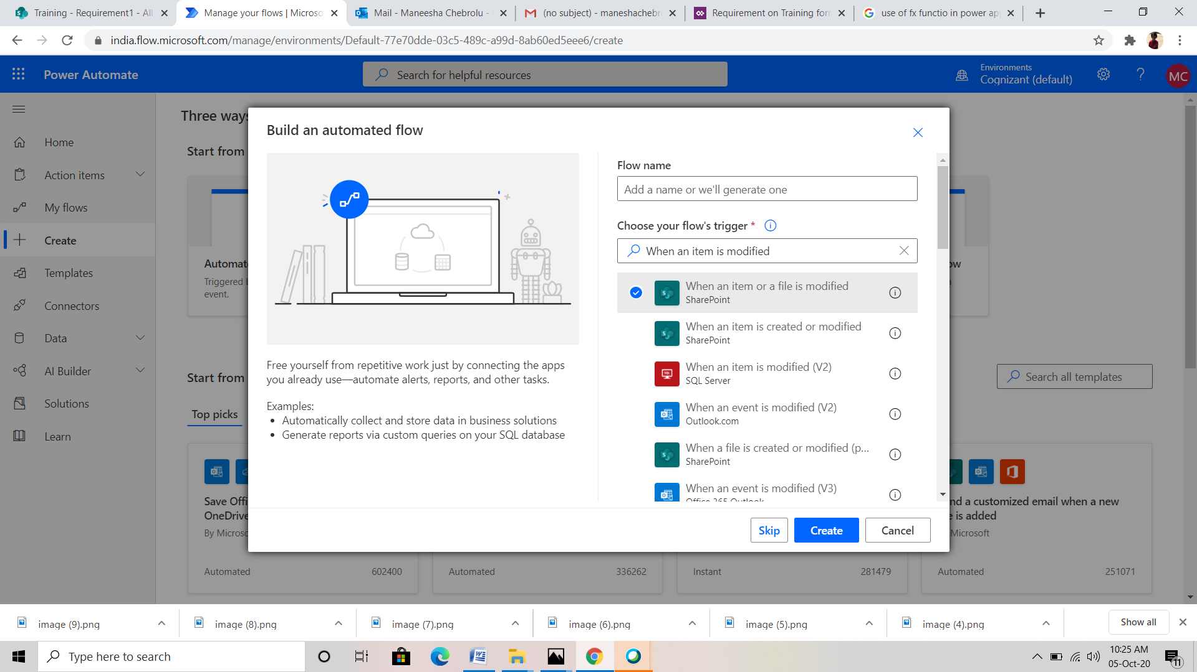

Creating flow:

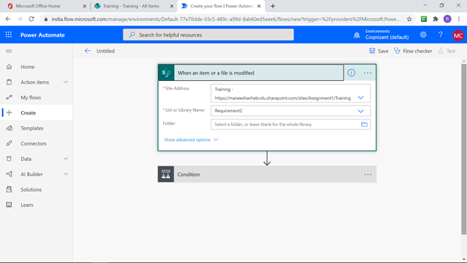

Select condition -> choose a value ->add dynamic value ->status value.

condition-> if yes-> add an action->Get items

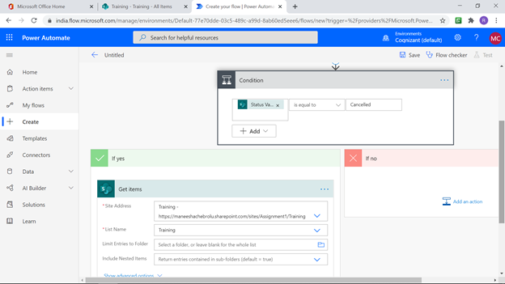

Next add an action-> Select condition -> choose a value ->add dynamic value

->Training Name

Next choose sent an email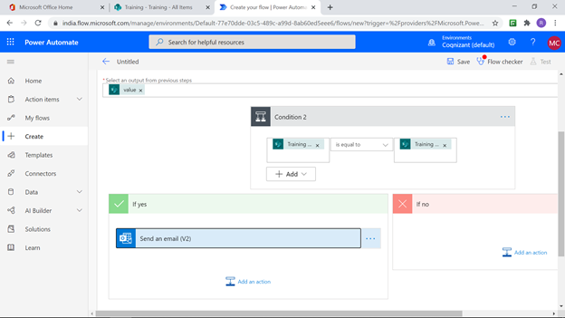

Fill the appropriate fields

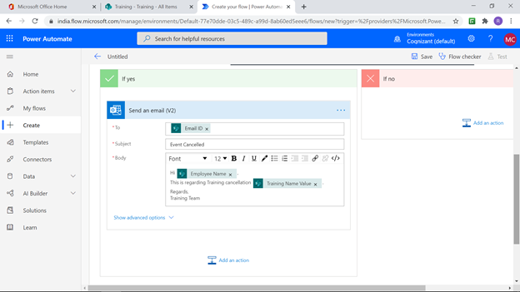

Add an action->update item

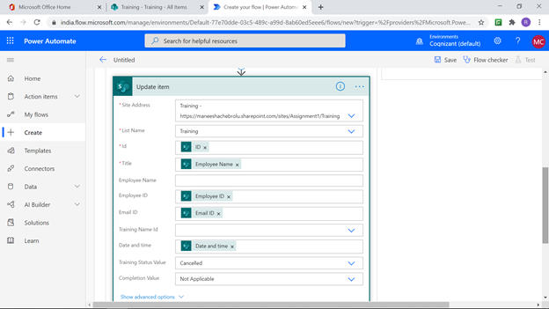

Save the automated flow

Go to our lists and update our lists with some data.

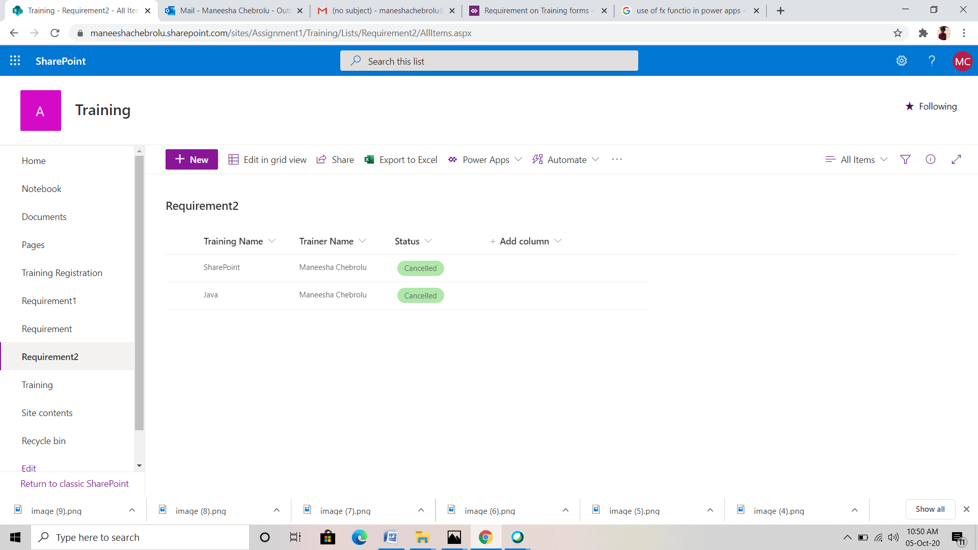

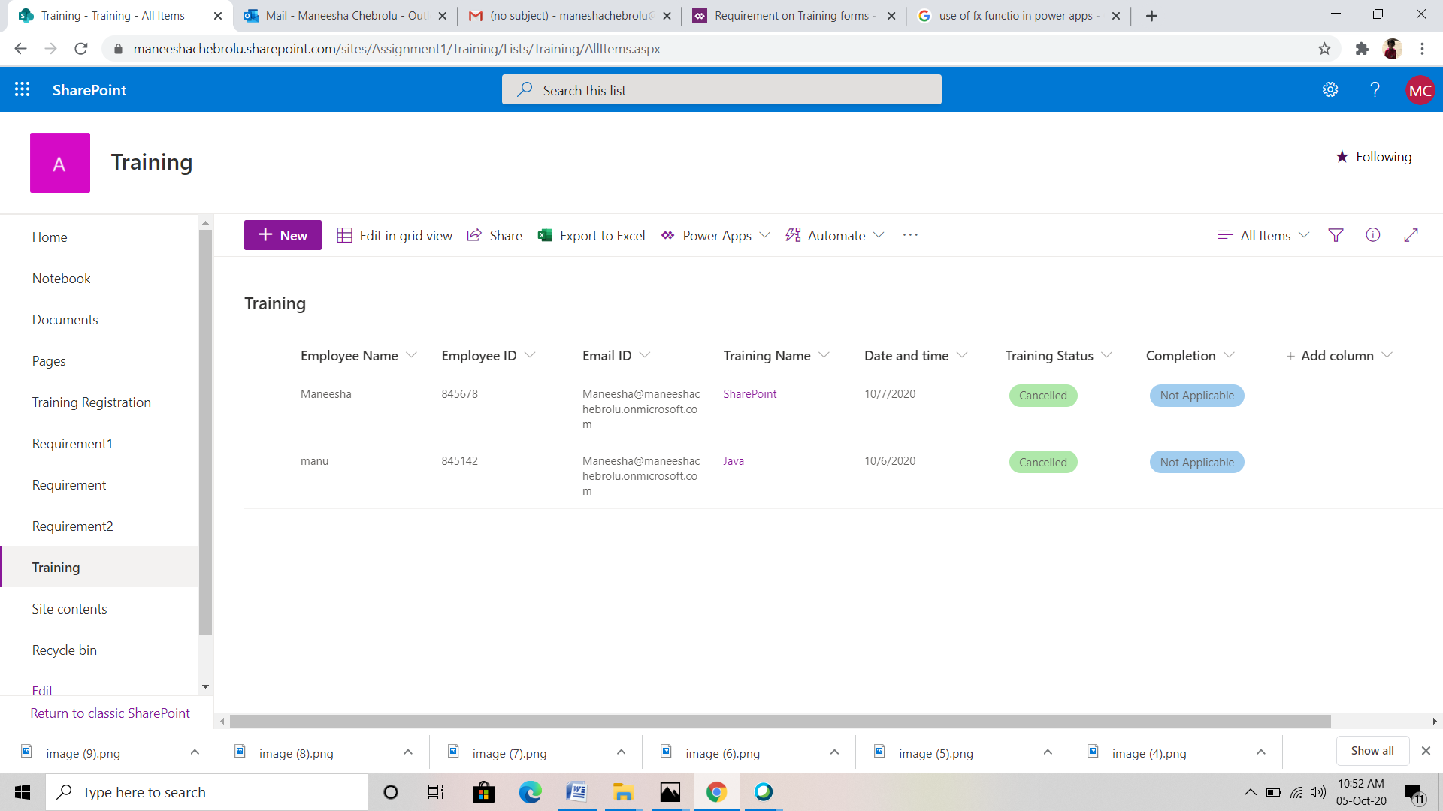

When the training details is edited in the requirements list its automatically reflected in training list then we recieve a mail using office 365.

